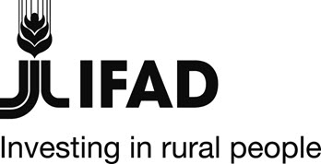 |  | 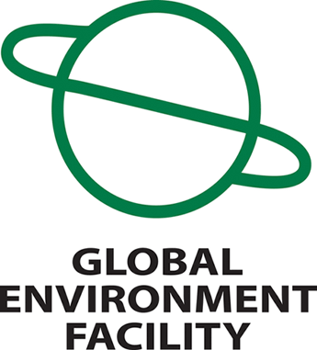

Republic of Niger

GRANT - NIGER - GEF 3383

Agricultural and Rural Rehabilitation and Development Initiative (PASADEM)

GEF Terminal Evaluation Report Summary

Map of project areas

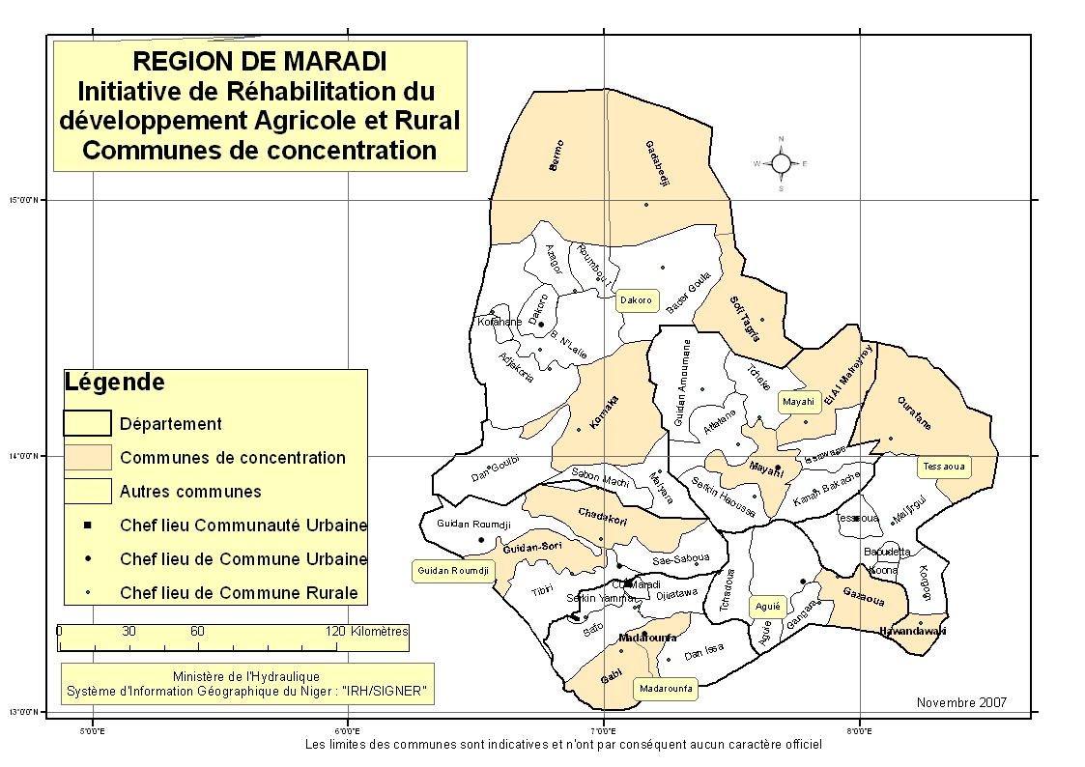
The project at a glance
Country | Niger
Project Name | Agricultural and Rural Rehabilitation and Development Initiative (PASADEM)
Key Dates
IFAD Approval | Signing | Effectiveness | Mid-Term Review | Original Completion | Actual Completion
04 September 2009 | 06 October 2011 | April 2012 | December 2014 | 31 August 2016 | 30 June 2016
Original Grant Closing | Actual Grant Closing
30 June 2017 | 31 December 2016
Project Financing
Loan | Million USD | 0 | % disbursed | 0
GEF Grant | Million USD | 4,2 | % disbursed | 98%
Actual Costs and Financing (USD ‘000)
Component | GEF Grant | Co-financing IFAD | Beneficiaries | Government | Total
Component 1. Mainstreaming SLM/NRM in development planning at departmental and local levels. | 917 | 1509 | 215 | 430 | 3 071
Component 2. Reversing land degradation through on-the ground investments at key agro-ecological sites | 1 677 | 5060 | 580 | 1160 | 8 477
Component 3. Promoting conservation agriculture and environment-friendly alternative income sources | 1 140 | 1510 | 164 | 530 | 3 344
Component 4. Project management | 466 | 504 | 72 | 144 | 1 186
TOTAL | 4 200 | 8583 | 1031 | 2264 | 16 078

Budget disbursed (USD ‘000)
Component | GEF Grant | IFAD | WFP | Beneficiaries | Government | Total
Component 1 | 438 | 21 169 | - | - | - | 438
Component 2 | 2 412 | 21 169 | 4 434 | 306 | - | 7 152
Component 3 | 617 | 21 169 | - | - | - | 21 787
Component 4 | 668 | 21 169 | - | - | 2 600 | 3 268
TOTAL | 4 135 | 21 169 | 4 434 | 306 | 2 600 | 32 644

Number of Beneficiaries
 | Target |  | Reached | Achievement rate
Adult Men | 136 000 |  | 130 578 | 96%
Adult Women | 102 000 |  | 119 048 | 117%
Youth (men and women) | 102 000 |  | 72 065 | 71%
Total | 340 000 |  | 321 690 | 95%
Project Objective
The overall and long-term goal of the project on environment and development is to address the interrelated problems of rural poverty, food insecurity and land degradation by promoting sustainable land management practices, with the aim of restoring, supporting and strengthening the productive and protective functions of the ecosystem resources in the Maradi region.
The immediate development goal is to reduce poverty and food insecurity in rural households in the Maradi region by empowering them to identify and adopt sustainable land management practices that are appropriate to the local context, and that will increase the productivity and profitability of their crops, livestock and forestry in the short term, while ensuring the long-term livelihood strategies and well-being of current and future generations.
The immediate environmental goal is to overcome the causes and negative impacts of land degradation in the Maradi region by addressing the obstacles and bottlenecks that prevent the good use of sustainable land management technologies.
Specifically, it involves: (i) complementing IFAD-financed investments and activities by generating global environmental benefits; (ii) build capacity for mainstreaming Sustainable Land Management (SLM) practices into productive landscapes at the local level; (iii) introduce innovative techniques for the sustainable management of arable land, rangelands and forests / woodlands in the main agro-ecological sites of the Maradi region; (iv) reverse the current trend of land degradation through a community and participatory approach to investment planning; and (v) improve the well-being of the rural population.
Country Partners
Executing Agency |  | Ministry of Agriculture  Regional Directorate of Environment, Regional Directorate of Livestock, Regional Direction of Agriculture,, University of Maradi and SLM Platform
NGOs/civil society |  | PROMODEL Fussa’a, ONG Tatali, PGEDER, ONG Yanahi, AJA, ADIPAC, Groupement marché rural de Dan Saga, ONG Karkara, AREN, ONG Goulbi.

Project overview
- As part of a Global Environment Facility (GEF 4) support to implement the Programmatic Approach to Sustainable Land Management (SLM), the Government of Niger and IFAD requested and obtained in October 2011, the transfer of an amount of US $ 4.2 million for the development and rehabilitation of agriculture in rural areas of the Maradi region. This funding, called the GEF Component, was implemented through the Food Security and Development Support Project in the Maradi Region (PASADEM). It aims to complement IFAD/Government investments in the Maradi region by generating global environmental benefits through the integration of SLM into development planning, capacity building at local level, investments for the adoption of innovative SLM technologies in agro-ecological sites and the promotion of conservation agriculture, which is an environment friendly source of income. Thus, the GEF component of PASADEM intervened in the departments of Madarounfa, Aguié, Dakoro, Mayahi, Tessaoua, Guidan Roumdji and Gazaoua and reached more than 320000 people.
- The implementation approach of the GEF component has been inclusive and in synergy with operational partners (PASADEM/IFAD, WFP, NGOs, Regional Services and MFIs) for technical activities and scientific partners (University of Maradi and the SLM Platform) for research, capitalization of experiences and evaluation of effects and impacts. For the implementation of the activities, the approach of outsourcing and delegating implementation responsibilities (known as faire-faire) was used through the signature of partnership agreements with NGOs and/or experienced associations with a strong pre-financing capacity for the animations and the construction of SLM works. SLM works are implemented through the Cash for Assets (CfA) approach in partnership with WFP. A Technical Assistance Agreement has been signed with the Regional Directorate of Environment. This Directorate appointed focal points to the project to ensure the technical follow-up of the activities and their sustainability in collaboration with the technical coordination team of the GEF component of PASADEM. At the local level, Village Management and Monitoring Committees (COGES), elected at the general assembly by the beneficiary populations, were set up to ensure local management and permanent monitoring of the developed sites.
- Despite the difficulties encountered in implementing the PASADEM GEF component, related to IFAD investment shifts in the region, this arrangement has been implemented in the best conditions through the selection of relevant actions and targeting in accordance with the SLM programmatic approach in the Maradi region, as well as the respect of the orientations given by the national and international strategic frameworks.
- After five (5) years of implementation, many results are currently assets in the Maradi region. These include the establishment of a regional SLM platform, the institutional capacity building of seven (7) NGOs and groups (AJA, ADIPAC, PGDER, PROMODEL, YANAHI, TATALLI, Groupement RNA de Dan Saga) for skills in the implementation of assisted natural regeneration (ANR) and three (3) NGOs (AREN, NGO Karkara and NGO Goulbi) for the restoration of degraded lands in the 36 village, 20 Communes and 6 departments, the recovery of degraded agro-sylvo-pastoral lands on 13,780 ha, production of 1,170,657 forest seedlings by local nursery growers, seeding of grass forage species on 14,446 ha, promotion of the ANR on 90 481 ha. The intervention of the GEF component also allowed to conduct tests in 83 Farmer Fielad Schools (FFS) and to fund 5 Income Generating Activities (IGAs). These achievements made it possible to reach a total of 321,690 direct beneficiaries (45,956 households), of which 41% were adult men, 37% adult women and 22% young women and men, representing a rate of 95%. With these results, the project's performance is very significant.
- Of the total amount of financing, the disbursement rate at project closing in December 2016 is 98.75%. The implementation of the GEF component is globally in line with the grant agreement, as demonstrated by the respect of disbursement procedures and the mobilization of the various co-financing funds. The investment cost ratio (90.24%) and administrative cost (9.76%) of the GEF component funding is slightly higher than the projected rate at project design (7.5% for USD 314 000). The management of the GEF component is quite satisfactory despite the significant operating costs that are mainly due to inflation, the longer implementation period of the project and the increase of the activities volume.
- The physical achievements of the project are: 90 481 ha of ANR, 7.530 ha of restored agro-sylvo-pastoral areas, 6 250 ha protected against Sida cordifolia, 13 780 ha of reclaimed land sown with herbaceous plants. 1,170,657 of forest seedlings produced and planted, 2,350 km of upgraded degraded sylvopastoral corridors, 140 ha of eucalyptus plantations deserted to support agricultural conversion of reconverted land, 15 km of firewalls. The funding also allowed to disseminate 11,000 improved stoves to reduce wood fuel consumption, restore 16 ha of pasture land and build 6 pastoral wells.
- Overall, there is a significant improvement in the baseline socioeconomic and environmental indicators of the logframe defined at the start of the project. This target category represents more than 52% of the people affected by the project activities. The implementation of SLM activities allowed to transfer more than 3 billion CFAF in the form of Cash for Works (CfW) and to significantly reduce household food insecurity in the project's localities. The average yield of rainfed crops increased by 20 to 80% depending on the crop (from 213 kg/ha to 459 kg/ha for millet). In terms of impact on the global environment, the region's biodiversity (flora and fauna) has improved in qualitative and quantitative terms with the reintroduction of extinct plant and wildlife species. Thus, where the GEF component has intervened, there is an exploitable and exportable surplus in terms of agricultural, pastoral and forest resources due to the significant production gains. The intervention of the GEF component of PASADEM has therefore brought improvements to the ecosystem resources in the intervention zone, thus creating better ecological services and benefits for rural households by improving soil cover. Also, the protection capacity of the plant cover against erosion and bad weather increased from 25% to 60%. The vegetation increase has a positive impact on carbon sequestration. Thus, the carbon footprint is positive (6 142 621 tco2eq of carbon), not including the enteric fermentation linked to the breeding activity. Animal feed capacity also improved with an increase in animal feed of over 18,789 Tropical Livestock Unit (TLU). The technical, institutional, legal and political environment has improved, paving the way for sustainable land management in the Maradi Region.
- The establishment of an innovative tripartite partnership with WFP and a partner NGO (AREN and Karkara) for the implementation of Cash for Work activities made it possible to exceed all the initial objectives in terms of land reclamation.
- In terms of improvement, it is currently necessary to consolidate the achievements made. This consolidation, capitalization and scaling up of activities is planned as part of IFAD's Family Farming Support Programme in Tahoua, Maradi and Zinder (ProDAF) regions. ProDAF, which began in 2015, will include new GEF funding from 2017, complementary to ASAP funding on climate change adaptation.
Lessons learned
At the strategic and implementation process level
- It is important to mention:
- The multi-stakeholder partnership with development partners (mainly WFP), specialized operators (NGO operators and farmer groups) and technical services at different levels. The technical assistance provided by IFAD, has been a strong lever in implementing support activities for beneficiary populations. This partnership is also a good example of collaboration between United Nations Agencies operating in the same region for sustainable land management;
- The establishment of a sharing and exchange framework with the operators, a practice inherited from the PPILDA (monthly meetings of project implementation stakeholders) has greatly facilitated the coordination and management of activities in the field; it has made it possible to ensure a certain coherence of the interventions.
- The establishment of an infrastructure management system (inputs and seeds bank) that puts farmers’ organisations at the heart of the process is a guarantee of the project’s achievements sustainability.
At SLM implementation level
- The lessons learned are:
- The fight technique against Sida cordifolia gave satisfactory results. Sida cordifolia is a very invasive species that cannot be controlled in a single year of intervention. It is therefore necessary to make a consolidation for several years, with a strengthening of herbaceous seedlings.
- The success of ANR offers opportunities for developing income-generating activities around agricultural products and timber and non-timber forest products. The effective involvement of the administrative and customary authorities, especially in the awareness-raising activities, favoured the scaling up of the ANR.
At the institutional level
- The lessons learned are:
- The documentation centre and large-scale sharing of results (workshops, exchange trips, websites, trainings, etc.) provide access to SLM knowledge and generates interest for practice with other stakeholders and even policy makers. This promotes the adoption of good SLM practices. The SLM platform is a multi-stakeholder consultation framework within which the documentation centre can evolve and prosper. It must therefore seek its autonomy beyond the resources granted by the project in order to play its full role.
- The project has successfully conducted Income Generating Activities financing experiments with women. These activities continue even with the cessation of project funding. Women currently have financial capital from which they can self-finance and thus develop their business activities while securing a sustainable income.
Conclusions
- Implemented in accordance with the project design report, the GEF component has reached and in some cases far exceeded its objectives allowing the realization of several operations reversing land degradation trends.
  - Significant achievements and visible impacts on the ground will allow (i) the resources of the ecosystems of the Maradi region to regenerate and (ii) provide better services and ecological and socio-economic benefits to households, especially the most vulnerable ones, while improving their livelihoods.
  - At the environmental level, the implementation of SLM practices has significantly improved and preserved the region's biodiversity and increased the capacity for climate change mitigation and resilience through the sequestration of carbon due to the vegetation cover increase;
  - The technical, institutional, legal and political environment has improved, paving the way for sustainable land management in the Maradi Region.
- It should be borne in mind that the support from the PASADEM GEF component is a temporary technical and financial assistance that reinforces the efforts already made by the populations and does not ensure the sustainability and scaling up of SLM in the region. Despite the efforts made by the various partners, there is still, in the Maradi region, major economic poverty and significant risks related to climate and prices.
- The project has achieved good results across all evaluation points, particularly the impact on poverty and food security, but also on the aspects of climate change adaptation, impacts on human and social capital as well as the replicability potential of the project. Thus the overall performance of the Project has been rated as satisfactory (5).
Recommendations
- Under the current conditions, SLM has played an important role in setting up sustainable livelihoods for vulnerable populations.
- To ensure the long-term financing of SLM practices and the consolidation of PASADEM GEF component, site management plans are drawn up and implemented by the beneficiary communities as internal mechanisms capable of making sustainable exploitation of the sites. This innovative approach allows the various recovered sites to self-finance the development work they need;
- The implementation of the GEF component also made it possible to understand that SLM actions, designed and carried out by the beneficiaries allows the long-term increase of crop, animal production and incomes;
- The implementation of the GEF component has also revealed that, so far, wherever the impacts are visible, there is a need to strengthen the technical, institutional and organizational capacities of the COGES to fully play their roles as production/marketing actors able to access credit or other types of financing to develop SLM;
- Calibration of the project results with the University of Maradi and the development of an ATLAS on ANR are underway. For this reason, the communication and results sharing workshop recommended to extend the agreement with the University of Maradi to validate the technical and socio-economic impacts of SLM good practices and give them scientific value in the perspective of scaling up actions.
- Thus, to facilitate the complete financial autonomy of populations, communities and institutions, the creation of capital and the financing of innovation are necessary. To do this, it is important to promote and develop IGAs with the revenues generated through natural resources management activities. This may be a way forward for the implementation of the ProDAF project.

TER Rating Matrix
Criterion | Rating
Project performance
- Relevance | 5
- Effectiveness | 5
- Efficiency | 5
- Sustainability | 5
Project impacts
- Households ‘incomes and assets | 5
- Human and social capital and empowerment | 6
- Food security | 6
- Agricultural productivity | 5
- Institutions and policies | 5
Overall impact of the project on rural poverty | 5
Additional evaluation criteria
- Gender equality and women’ s empowerment | 5
- Access to markets | n/a
- Innovation | 5
- Potential for scaling-up | 6
- Environment and natural resources management | 5
- Adaptation to climate change | 6
- Targeting and outreach | 5
Partners performance
- IFAD’ s performance | 5
- Government performance | 5
Overall project performance | 5

